Anthony Le

ST 511

10/04/2016

Homework 1

Exercise 3:

1. No, because this is an observational study where the investigators observed subjects and measured the variables of interest (number of bathrooms verse blood pressure) without assigning treatments to the subjects. Overall, the individuals’ condition of housing is out of the investigator’s control.
2. Wealth of the individual, richness of diet of the individual, work environment and stress coming home from work, how many people are living in the house, what is the gender ratio within a house, how much time an individual uses the bathroom.

Exercise 6:

1. No, because the investigators drew participants for the study from specific groups, e.g. patients enrolled in a drug abuse program and drug-free volunteers. This study is observational where it is possible that the drug users were different from the non-users in other ways besides drugs, thus, a causal relationship cannot be drawn. Even though the investigators treated the marijuana group, it was not a randomized experiment and the control was not treated at the same time.
2. No, because the samples are volunteers from specific groups e.g. patients enrolled in a drug abuse program and drug-free volunteers, not random samples. Therefore, the results cannot be generalized to other 14- and 16-year-olds. In addition, these specific populations (or groups) cannot be used to generalize to other 14- and 16-year-olds outside of these groups.
3. Happiness of the child, family status and stability of the child, success of child in school, how often are individual marijuana users actually using, what is the gender ratio among both groups.

Exercise 12:

1. This study was a randomized experiment where male volunteers with high blood pressure were randomly divided into two groups. Each group was given a specific treatment, fish oil diet and regular oil diet, thus, a cause-and-effect relationship can be inferred between the type of oil diet verse blood pressure. The results of this study might be important because the men who were treated with the fish oil diet showed no change or some decrease in blood pressure while the regular dieted men showed no change, little decrease, but mainly some increase in blood pressure. In conclusion, the fish oil diet caused a reduction in blood pressure for the men who volunteered which is convincing and useful conclusion that can be used for further studies to establish acceptable causation.

Boxplot for ex0112 data of Diet vs Reduction in BP

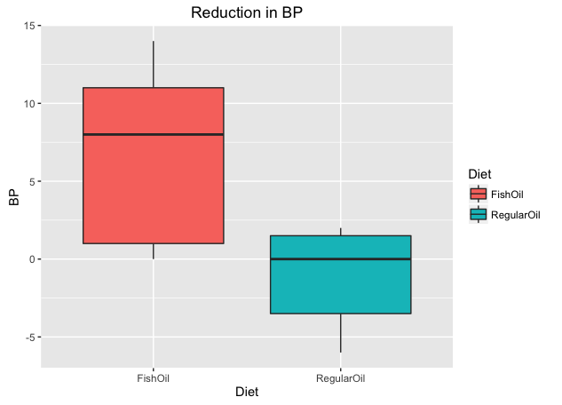

R Code

# load Sleuth3 package

# data in exercise 12

>library(Sleuth3)

>ex0112

# load ggplot2 package

# side-by-side boxplot

>library(ggplot2)

>ggplot(ex0112,aes(x=Diet,y=BP)) + geom_boxplot(aes(fill=Diet))+ ggtitle("Reduction in BP")

# two-sided t-test

>t.test(BP~Diet,data=ex0112,var.equal=TRUE)

Statistical Conclusion: As evident in the boxplot shown above, the data provides convincing evidence that receiving the fish oil diet rather than the regular oil diet lowered BP more (two-sided p-value=0.009861 from a two-sample t-test). The estimated mean reduction in BP of the men on the fish oil diet is 7.71 mmHg more than the mean reduction in BP of the men on the regular oil diet (95% confidence interval: 2.225174 to 13.203398 mmHg).